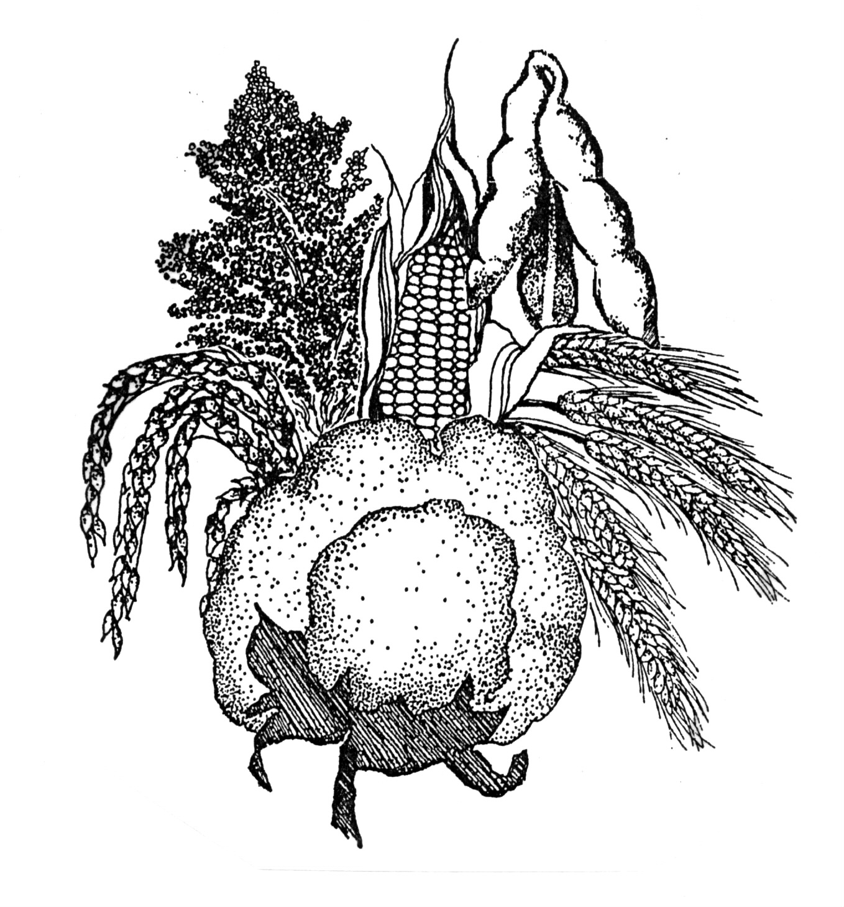
Delta Ag Expo Corporation
APPLICATION FOR 2020 EXHIBIT SPACE
P. O. Box 1678, Cleveland, MS 38732-1678
Phone: Laura (662) 721-2337 Fax: (662) 843-5611
email: owensl@bellsouth.net

COMPANY NAME: _______________________________________________________________________________________
Contact Person: _________________________________________________Title: ____________________________________
Mailing Address: ___________________________________ City____________________ State____________ Zip___________
Phone _____________________________ Cell Phone ______________________________ Fax_________________________
email address: ___________________________________________________________________________________________
Product Description:
Please give a full description of the products/services you wish to exhibit and attach brochures or pictures for jury purposes.
Misrepresentation may result in cancellation of space if granted on inaccurate information. ______________________________
___________________________________________________________________________________________________________________________________________________________________________________________________________________________________________________________________________________________________________________________

Your application will be placed in one of five divisions according to the above description:
_____ (1) Equipment/Machinery Sales and Service
_____ (2) Chemical Sales
_____ (3) Seed/Fertilizer Sales
_____ (4) Service to Agriculture
_____ (5) Educational/Informational
*In your opinion, which division best describes your exhibit? (please check only one division)
The Delta Ag Expo Committee reserves the right to change your division according to your description of services.

EXHIBIT SPACE RATES:
1. Standard Inside Booth Space……………….10’ x 10’ @ $4.25 sq.ft. = $425.00
Inside exhibit space rental includes the following:
- 8’ high draped backdrop
- 3’ high side-draped booth divider
- one standard company sign
- one 8-foot draped table
- two chairs
- one waste can
- general cleaning of exhibit hall
- electrical outlet
2. Outside exhibit Space…………………………25’ X 50’ @ $125.00
- located in parking area adjacent to exhibit hall

SIZE INSIDE EXHIBIT SPACE REQUIRED: ______________________________
SIZE OUTSIDE SPACE REQUIRED: ____________________________________

All applications will be reviewed each year by the Delta Ag Expo Board of Directors and exhibit space will be filled as the Executive Committee chooses to keep a desired balance and variety of exhibits. The Delta Agricultural Exposition Corporation reserves the right to refuse any application that may be made.

Sign below acknowledging that you have read and fully understand the contents of this application.

__________________________________________ ______________________________________________
(Print or type name) (Signature of company representative)
RETURN APPLICATION TO: Delta Ag Expo Corporation
Attention: Laura Owens
P. O. Box 1678
Cleveland, MS 38732-1678
FOR SHOW MANAGEMENT ONLY:
Date Received: ____________________ Date Space Assigned: _____________________ Number Assigned: _____________________________

